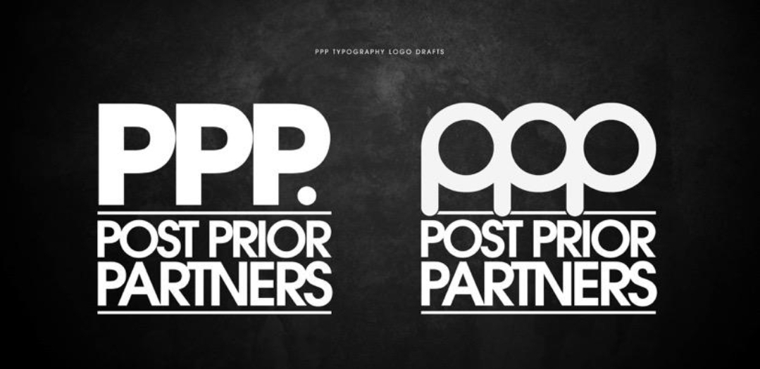
(Contract Agreement for Self Employed Courier/Limited incorporation)

Self-employed status

Couriers are engaged by Post prior Partners Limited to deliver and collect behalf of PPP Limited. A self-employed person or incorporated Company is not employed by PPP. Limited.

Couriers are responsible for all income tax and national insurance contributions in respect of any fees that they are paid by the Company/PPP.

As well as providing a service to PPP. Limited, Couriers may carry out or provide a similar service for any other individual, firm, partnership or company.

Sub-Contractor is responsible for the provision of safety equipment, protective clothing and adequate industrial accident insurance cover for him/herself and anyone authorised by them to perform all or any part of the services.

The sub-contractor also hereby confirms that he is a registered self-employed person and therefore responsible for his/her own tax and national insurance.
Sub-Contractor agrees to be responsible for his/her expenses and Value Added Tax

The Sub-Contractor’s relation to PPP of a self-employed person and shall be responsible for all Income Tax and National Insurance or similar taxes or contributions in respect of the consideration payable hereunder and the Sub-Contractor hereby indemnifies the Company in respect of any claims that may be made by the relevant authorities against the Company in respect of Income Tax or National Insurance or similar taxes or contributions, including interest and penalties, relating to the services of the Sub-Contractor hereunder.

All payments made under this Agreement are exclusive of Value Added Tax.

Parking tickets/Fines & Sourced van from P.P.P.

The Company is not responsible for any parking tickets or fines occurred by the Sub-Contractor at any time while at collection or delivery. It is the Sub-Contractor’s responsibility to inform the company if issues are collecting or delivering and will advise accordingly. It is the sub-contractor reasonableness for any fines or penalties issued.

If a vehicle is provided to a sub-Contractor.
He or she is responsible for the fuel, oil and ad Blue. We will carry out a vehicle inspection to establish the condition before vehicle is handed over. This will be filmed and sent to each party via email to log the condition before the vehicle is handed to subcontractor. any damages incurred by Sub-Contractor after inspection will charge at price of repairs.

KPI, COMPLIANCE, Theft & Pay.
If caught with unauthorized parcels in your possession, it may lead to dismissal or prosecution by the contractor.
COMPLIANCE - Customers are not obliged to be in picture if requested. However a door open with parcels in customer hands or on the floor next to an open door is the only way to deliver a parcel correctly.
Missing or not delivered within company set guidelines could lead to the courier being fined up to a 100% of items retail cost.
KPI - Do not deliver a parcel in a time slot if it displays white or red.
If you do deliver in red or white this will affect your KPI's and ultimately drop your parcel rate by 10p per parcel or overtly be dismissed from working with P.P.P.
KPI'S data is collected daily however hermes review change in pay, if kpi are not taking seriously.
PARCEL RATE & PAY.
- A rate per parcel to be agreed with the driver.
AGENCY FEE/ADMIN FEE.
-£7 a day if delivered between 0 - 49 parcels.
- £10 a day if delivered between 50 - unlimited parcels.
- Earnings are paid every 28 days on the second Friday of the following month.
- First day training won't be paid if you decide its not for you on day one.
- If the courier decides not to continue at any time after you commit a term with P.P.P . And work less than a calendar month.. You will receive pay but less, first three days training.
-Leaving abruptly at any time without at least 14 days' verbal notice. Could lead to a fine of up to £100.
Do not start to scan a parcel without MANIFEST.
Hermes DEDUCT rate if parcel are delivered in RED or WHITE.
No daily screenshot summary no pay for that day.
SIGN OUT Daily, after END OF DAY SIGN OUT.
Download Manifest daily before 9:15am regardless of what time you start.
Saving route problem -" Please ask".
Insurance.

Freight forwarding/Courier Delivery insurance (Hire and Reward) is required to deliver and collect parcels and/pallets on behalf of P.P.P.Limited. Only Hermes Couriers/contractors are compulsively provided an opt out blanket Couriers insurance at a monthly rate of £1 a day to couriers if person or couriers do not have their own. This will be deducted from your from monthly earnings, only charged the days you work.

Courier Liability.

If, as a result of negligence or carelessness, a Courier causes damage to a customer’s or third party's property, or causes injury to a customer or third party, the Courier is liable to the customer or third party for that damage or injury. We suggest taking out a public liability insurance.

It is a condition precedent to liability that you obtain written evidence to ensure that any- contractors soured by you shall maintain insurance on the same basis as provided herein.

MISCELLANEOUS
This Agreement contains the whole agreement between the Sub-Contractor and the Company and the supersedes any prior agreement between the parties whether written or oral and such prior agreements are cancelled as from the date hereof and both parties acknowledge they have no claim against the other in respect of any other previous agreement.
DECLARATION
between- Post Prior Partners. trading as Post Prior Partners Limited (hereinafter called the Contractor)

This contract is for serviced made this day

Date ./___/___/___/

Name.
_________________

Address.
______________________________________

______________________________________

______________________________________

Vehicle
Make __________________________
Model _________________________
Registration _____________________
Whereas the Contractor undertakes to pay the subcontractor as per terms agreed for services provided in pursuant of the Contractor’s business and to abide by all rules and regulations and means of operating as stipulated by the Contractor or his/her representative.

The parties agree and intend to be bound by the foregoing Contract for Services.

Contractor:

Name: CARLTON RICHARD'S

Signed:

Dated:

Sub contractor:

Name:

Signed:

Dated:

Post prior partners Ltd

Registered in England and Wales.

